**Laboratory work 1.** ERD diagram.

1. **Identify Entities:**

* Airport
* Airline company
* Flight
* Booking
* Ticket
* Passenger
* Baggage
* Booking_update
* Passenger_security_check
* Baggage_security_check
* BoardingPass

1. **Determine Attributes**

* Airport: Id(PK), name, country, city, data_updated, data_Created, state
* Airline company: name, country, data_updated, data_Created
* Flight: id(PK), airline_id(FK), departing_airport_id(FK), arriving_gate, arriving_airport_id(FK), departing_gate, scheduled_departure_time, scheduled_arrival_time, actual_departure_time, actual_arrival_time, data_created, data_updated
* Booking: Id(PK), status, booking_platform, price, data_created, data_updated
* Ticket: Id(PK), booking_id(FK), flight_id(FK), passenger_id(FK), seat_number, boarding_time, data_created, data_updated
* Passenger:id(FK), first_name, last_name, gender, birth_date, country_of_citizenship,country_of_residence, passport_number, data_created, data_updated
* Baggage:id(PK), ticket_id(FK), weight, data_created, data_updated
* Booking_update: id(PK), booking_id(FK), description
* Passenger_security_check:id(PK), passenger_id(FK), status, data_created, data_updated
* Baggage_security_check: id(PK),baggage_id(FK), check_status, data_created, data_updated
* BoardingPass:boarding_pass_id (PK), boarding_time, data_created, data_updated

1. **Normalization and Identify Relationships:**

Airport –Flight (one to many)

Airline – Flight (one to many)

Flight – Ticket (one to many)

Booking – Ticket (one to many)

Passenger – Ticket (one to many)

Ticket – Baggage (one to many)

Baggage – Baggage_security_check (one to one)

**Изображение выглядит как текст, снимок экрана, программное обеспечение, Мультимедийное программное обеспечение

Содержимое, созданное искусственным интеллектом, может быть неверным.**

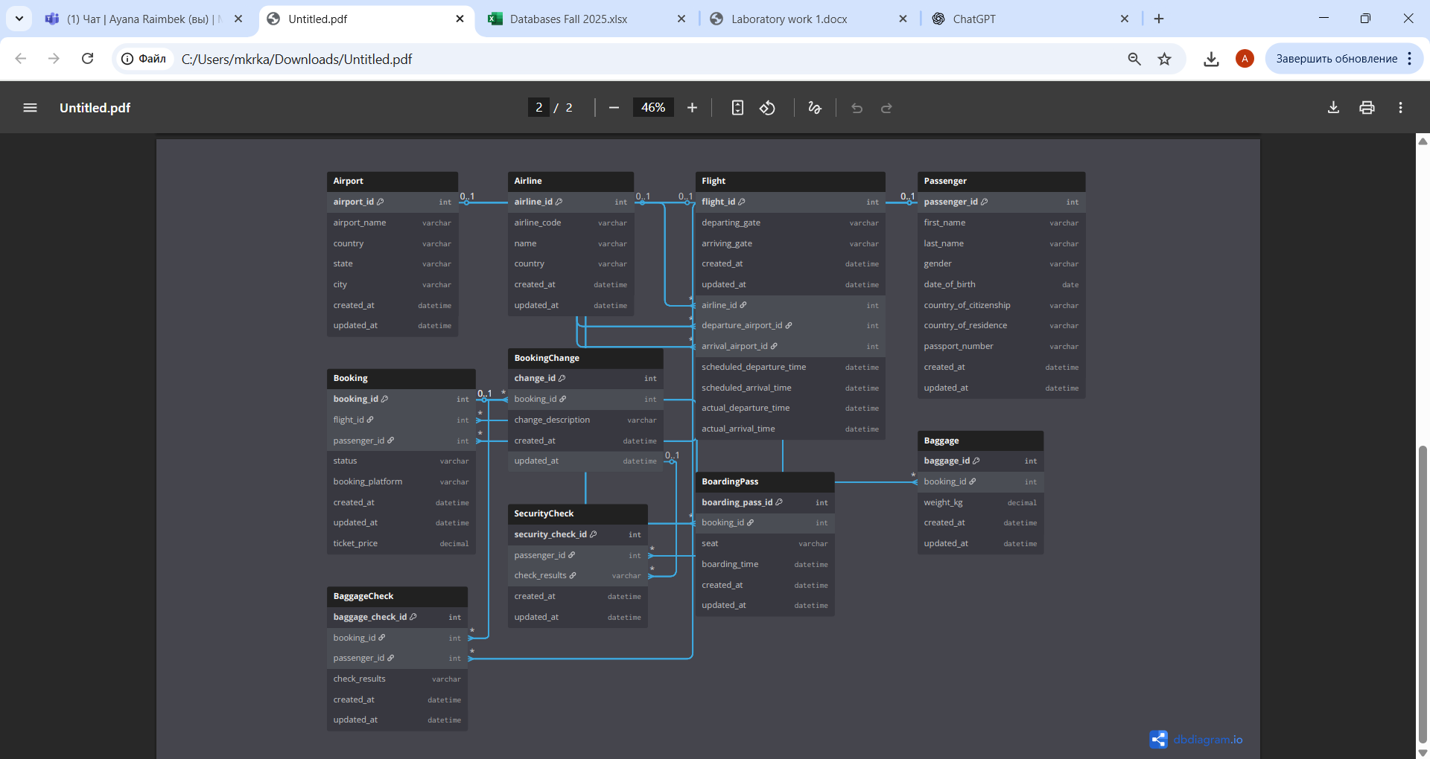

1. **Documenting diagram:**

**Entity-Relationship Diagram (ERD):**  
The ERD has been created using a tool such as Diagram.io. Each entity is represented as a rectangle containing a list of attributes, with primary keys (PK) and foreign keys (FK) clearly indicated. Relationships between entities are shown using lines, with appropriate cardinality labels.

**Conclusion:**  
This document provides a description of the core components of the airport database, including entities, attributes, relationships, and normalization to the Third Normal Form (3NF). Based on the specification given, a visual ERD diagram can be created. This solution fully meets the requirements set for Laboratory Work 1.